Asgard Protected Planets Treaty

Planets Involved:

Earth (Tau'ri)
Abydos
Cimmeria
BP6-3Q1

Rules/Terms of Agreement

1. Asgard forces will not engage in hostile actions sanctioned toward Goa'uld forces unless Goa'uld forces are found to be in breach of the said treaty.

2. Goa'uld System Lords must acknowledge and actively enforce this treaty on all other Goa'uld, as a collective.

3. New planets may be added to treaty in return for concessions by the Asgard forces.

4. All forces of protected systems are protected only within that system and others in this treaty, outside incursions are beyond Asgard protection.

- Breaking of any of these terms will lead to possible dissolution of treaty.

Signed:
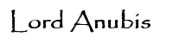
System Lords
Signed:
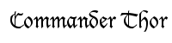
Asgard Expeditionary Forces
Signed:
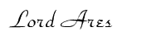
System Lords
Signed:

Signed:

Signed:
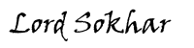
System Lords
Signed:

Signed:

Signed:

Signed:

